Computer Applications Technology

Southview High School

**Grade 10**

**June 2024**

**PRACTICAL TASK**

*Time: 1,5 HOURS Marks: 50*

This paper consist of 5 pages (title page included)

**Instructions and information**

1. Save your work at regular intervals.
2. Read through each question before answering or solving the problem. Do not do more than is required by the question.
3. Note that no printing is required.
4. Note that if data is derived from a previous question that you cannot answer, you should still proceed with the questions that follow.
5. Formulas and/or functions must be used for all calculations in questions involving spreadsheets unless specified otherwise – in other words do not manually calculate and type in the answers!

## Please note:

You will receive together with the question paper an examination folder called **DataTech**, which contains the following files:

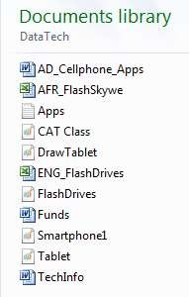

This folder will be referred to as your *exam folder*.

## Theme: Information about technology

*The CAT learners are responsible for keeping the school community members up to date with new technology and helping them to use it. This means that information evenings will need to be held, and articles written for the school newspaper.*

# Question 1

Open the document **TechInfo**.

* 1. Change the page size to A4 and set all the margins to 2.5 cm. (3)
  2. Add the words ‘Tech Info’ right-aligned in the header. (3)
  3. Change the font type of the WordArt to Arial. (1)
  4. Replace all occurrences of the whole word ‘phone’ so that they will appear in red. (2)
  5. Add automatic page numbering in the format ‘Page X of Y’, centred in the footer. (4)
  6. Change the style of all paragraph headings that have been formatted with the

*Heading 2* style, to the *Heading 1* style. (2)

* 1. Swop the order of the two highlighted paragraphs under the heading *E-books /*

*Digital books* on page 1, maintaining correct spacing. (1)

* 1. Replace the numbering of the five items under the sub-heading *Advantages of e-*

*books* with bullets. Use the Webdings symbol 105 with 12 point font size (). (4)

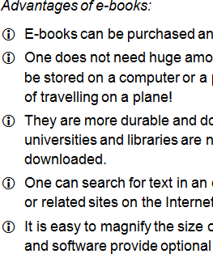

* 1. Format the first paragraph under the heading *E-book reader* using the style of the second paragraph (under the same heading). (1)
  2. Ensure that the heading *Netbooks* will always appear at the top of a new page. (1)
  3. Remove the soft Enter that was used in the first paragraph under the heading

*Netbooks.* (1)

* 1. Smart quotes have been used in the paragraph under the heading *Netbooks*

on page 2.

Locate these and replace them with the correct straight quotes. (2)

**Save and close the document. [25]**

# Question 2

Open the spreadsheet **ENG_FlashDrives** and do the following:

* 1. Format the date in cell A1 to display in the format 5 June 2012. (3)
  2. Enter the cellphone number *0821234567* in cell F1. (1)
  3. Merge cells A2:G3 and place a red border around the merged cell. (2)

2.4 Make the headings in cells B4:G4 run in the opposite direction (so that they read

from ‘bottom to top’). (1)

* 1. Wrap the contents of cell E4. (1)

The headings in columns B to G will then appear as follows:

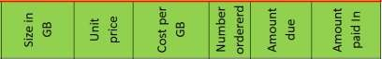

* 1. Format the prices in column C so that no decimal places are shown. (1)
  2. Calculate in column D the cost per GB for each of the flash disks, using their prices

and sizes in GB from the previous two columns. (2)

* 1. Calculate in column F the amount owing for each of the flash disk orders, based on

the number ordered (column E) and the unit price in column C. (2)

* 1. The amounts paid in column G were accidentally formatted as Euros.

Change the currency symbols to Rand (R) in this column. (1)

* 1. Add a function in cell B25 to determine average cost per GB of a flash disk, using

the data in column D. (2)

* 1. Add a function in cell B26 to determine total amount due (column F).

Ensure that the result displays correctly. (3)

* 1. The school is given 5.5% of the total amount due.

Add a formula in cell B27 to calculate the amount due to the school. (3)

* 1. Add a formula in cell B28 to determine the total amount still to be paid in, taking into account all the payments already made (column G). (3)

**[25]**

**Save and close the document.**

**TOTAL: 50**